**Mansoura University**

**Faculty Of Engineering – Computer and Control Systems Department**

**T28**

***Report about training Project***

**GCS Antenna Control System**

***Prepared By***

1- Abdelrahman Sedky

2- Ahmed Maged

3- Farha Emad

4- Mohsen Youssif

5-Toka Mahmoud

***Under Supervision of***

**Eng. Hany Mohamed Anees**

**September 2022**

* **Diagram

  Description automatically generatedWhat is the Antenna?**

Antenna is a structure used in transition of guided waves in a transmission line to free space propagation electromagnetic wave and vice versa.

* **Project overview:**

**antenna control system for tracking the satellite using two methods:**

* **Auto tracking method by Arduino :** Code to control the speed and direction of the antenna's movement.

The Controller accepts manual positioning of the antenna, by means of two rotary encoders, Azimuth and Elevation. It can automatically track satellites, when connected by USB to a PC running satellite tracking software.

The controller outputs a response on serial, for the tracking software to display the real antenna position on the screen.

* Diagram

  Description automatically generated**Manual tracking method:** Controlling the direction of the antenna by switches and controlling its speed by potentiometers.
* **System Flow Chart:**

**The system is divided into three stages:**

1. **First Stage:**

* **Stage requirements:** automatic control in Azimuth axis
* **Altivar interface circuit**
* **Code that automatically controls:**
* The direction of movement, whether counterclockwise or clockwise, according to the current angle and the required angle, given manually in the code.
* The motor speed depends on the distance of the current angle from the required angle.
* The time required to run the motor until it reaches its destination.
* **Stage hardware circuit:**



* **Stage code:**

1. **Second Stage:**

* **Stage requirements:** automatic and manual control in Azimuth and Elevation axes

**Two states :**

* **In automatic state** :Code to control movement in the direction of the Azimuth axis by determining the direction, speed and time required for movement and another code for Elevation axis**.**
* **In manual state** : Circuit to control the movement of motors in the Azimuth and Elevation axes.
* **Stage hardware circuit:**

* **Stage code:**

1. **Third Stage:**

* **Stage requirements:** manual control in Azimuth and Elevation axes and labview GUI
* **LabView System Block to :**
  + Read encoder position using serial port .
  + Compare encoder angle with requaired angle given by user and send f,r or s to arduino .
* **Code to recive data from serial port and control motor direction.**
* **LabView GUI:**

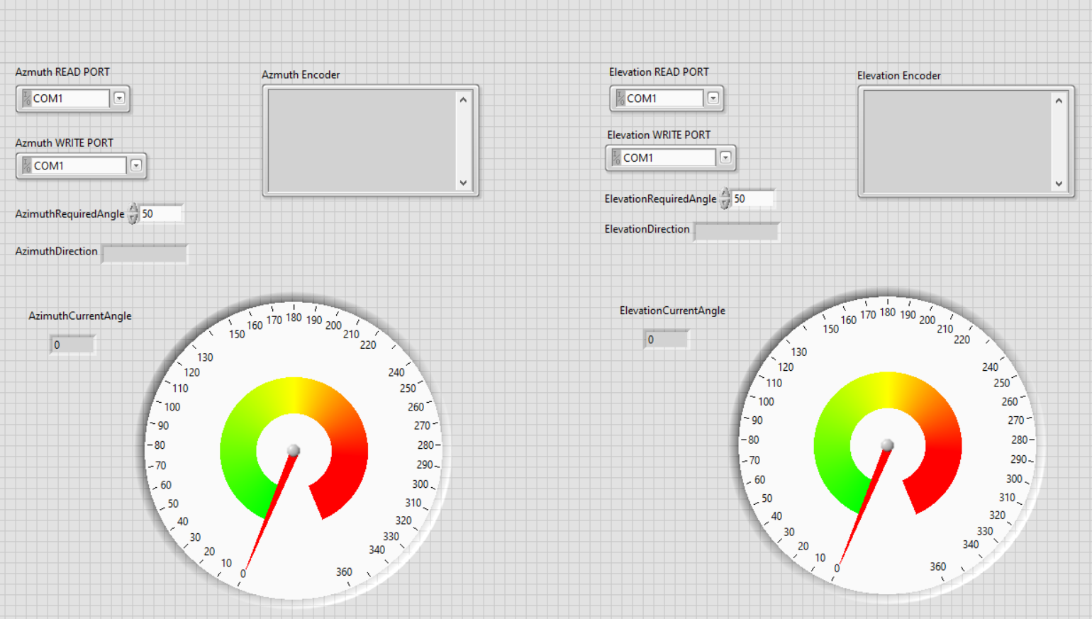

* **Diagram

  Description automatically generatedDiagram

  Description automatically generatedLabViewDiagram, schematic

  Description automatically generated Block Diagram:**
* **A picture containing text

  Description automatically generatedStage code:**

1. **Final stage:**

* **Stage requirements:** 
  + Code to control movement in the direction of the Azimuth axis by recive direction(f,r,s) from labview and presenting encoder current angle on LCD and another code for Elevation axis**.**
  + Manual full circuit.
* **Stage code:**

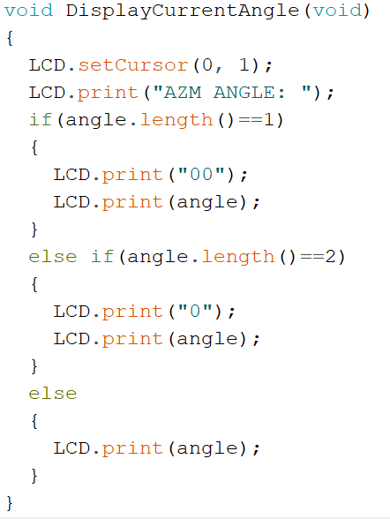

* 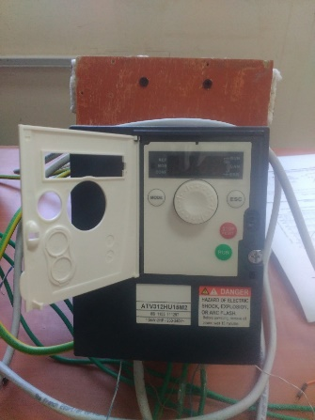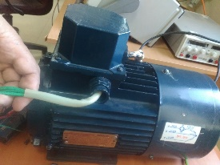**System components:**

1. **2 Motors :** to control movement in Azimuth and Elevation axes.
2. **2 Motor driver (Altivar) :**

its main functions are:

Figure motor

1. Start/ stop the motion.

Figure Altivar

1. Regulate the speed
2. **Diagram, schematic

   Description automatically generated**Protection of the motor using internal limit switches
3. Safe the energy for variable torque applications.
4. Adjusting operating speed range
5. Acceleration and deceleration ramp times.
6. Reverse rotation
7. Diagram

   Description automatically generated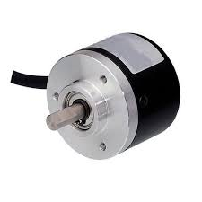**2 Optical Encoder :** to determine the angle of the motors .

Figure 3 Optical Encoder

1. **2 ARDUINO :** to automatic control Elevation and Azimuth motors direction and speed .

1. Diagram

   Description automatically generated**2 LCD :** To display the Encoder current angle.

Figure 4 LCDs

1. A picture containing schematic

   Description automatically generated**3 Switches:** to control manual/ auto state and Elevation and Azimuth direction counterclockwise/ clockwise.

1. **2 Potentiometers:** to control motors speed.

Figure 5 Switches

Figure 6 Potentiometers

1. **4 Opto-** **coupler**: To isolate the Arduino circuit from the ATV circuit.

Figure 7 Opto-coupler

1. **2  Operational Amplifier :** Increase the voltage output from the Arduino.

Figure 8 Operational Amplifier

1. Diagram, schematic

   Description automatically generatedDiagram, schematic

   Description automatically generated**4 Relays 8 pin:** They act as switches to determine the direction of movement in both axes.

1. Diagram

   Description automatically generated**3 Relays 5 pin:** 2 of them to control the speed and one to to let the controller know the system in which state, automatic or manual.

1. **2 LEDs :** As an indication of the state manual or automatic.

**13. 4 Limit switches :** They protect the motors from exceeding the acceptable angle range in real system .

In our case we handle that through labview.